Character Name: Thundrax Sabor

Race: Blue Dragonborn

Class: Paladin- Oath of Devotion

God: Helm  
Eye Color: Emerald Green

Height: 6 foot 6 inches or 1.9812 meters (according to google)

Weight: 260 pounds or 117.934 kg

Shape of head/color of skin

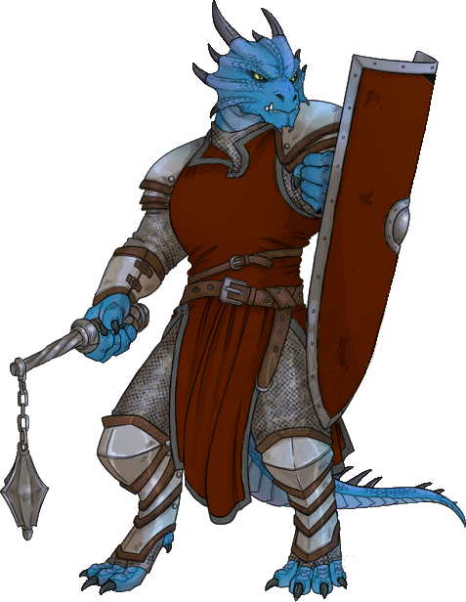

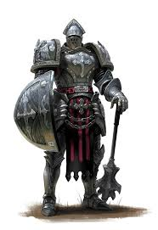

-similar sized shield, plain steel shield not decorated

Sword used (longsword -used 1 handed)

The Watcher's Blade  
  
"This ancient longsword has a golden tinted blade with ancient runes etched into the blade faintly glowing but only noticeable if observed very closely. The guard of the sword curves slightly up at the end with the center of the guard on each side having a small ruby encrusted into it. The hilt of the sword is covered in a red leather that never seems to wear down and the pommel of the sword is a small steel shield with a small engraving reading "Helm" on the very bottom"

Wearing half plate armor -no helmet, no gauntlets, similar looking the chest piece, metal skirt and shoulder pads to this the without the leather underneath

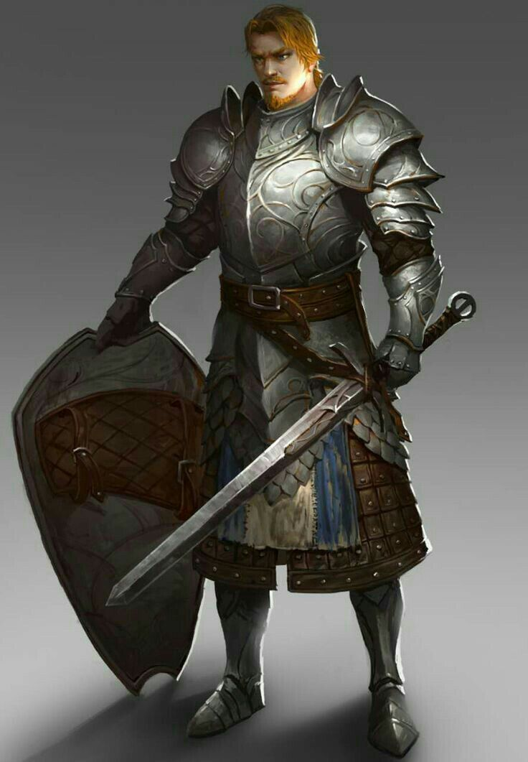

Picture

-Thundrax is looking forward

-shield on back

-Sword in both hands, held vertically with the tip of Watcher’s Blade long sword on ground

-looks stoic